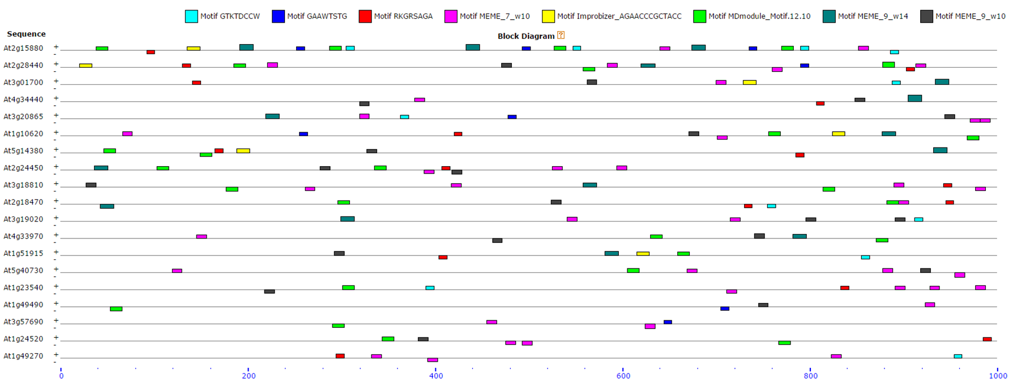Figure S1. The positions of identified motifs in each promoter sequence.